# **Finding the most appropriate venues to film a movie in Bogotá**

# **Santiago Muñoz**

# **November 12, 2019**

# **Introduction**

# **Background**

Finding appropriates venues to film a movie could be hard work if you don’t have enough information about the venues allowed to do this activity. It could be harder if a company wish to film in diverse cities or countries. Therefore, it is important to search and analyze what venues could be use it considering aspects like availability, visual impact, transport and others. This information can be used for film companies interested in filming in Bogota, Colombia.

* 1. **Problem**

A film company wishes to film some videos for a movie in Bogota, Colombia. They want to do these videos in venues like restaurants and bars close to Chapinero, which is a location in Bogota. They would prefer that these places can carry out this type of activity and see them on a map. They also want to see the classification of the venues considering their location and type. This project aims to show the most appropriate venues to fil this movie considering the customer considerations.

* 1. **Interest**

Film companies and people who are interested in filming professional videos for movies, or audiovisual projects in Bogota, Colombia.

# **Data acquisition and cleaning**

* 1. **Data sources**

The data that we are going to use is a table provided by the website: datosabiertos.bogota.gov.co, which is a website where you can find official data sets of different topics in Bogotá. The data set contains rows about venue identification, location name, location of the venue, venue address, the latitude of the venue, length of the venue, type of venue and the official website of each venue.

* 1. **Data cleaning**

The data was downloaded only from one page. However, it was necessary to delete some rows and change the name of others. It is important to mention that the data was in Spanish because the home page is a Colombian website. However, the data referred to addresses, proper names and types of places, so it is not very difficult to understand.

* 1. **Feature selection**

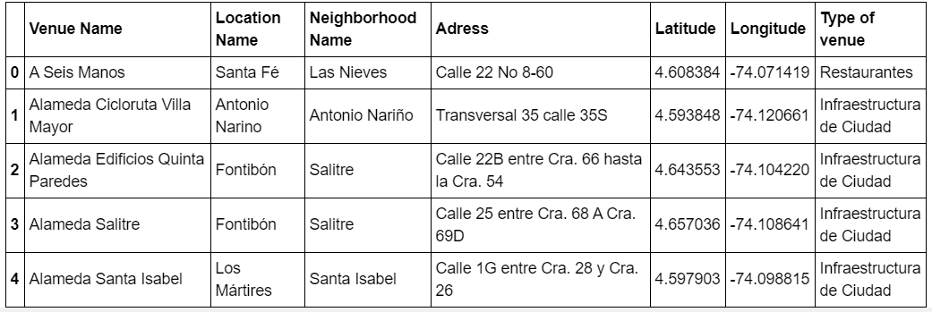The data was organized so that was possible to see in a graphic the quantity of each type of venue. Below is shown the head part of the general table.

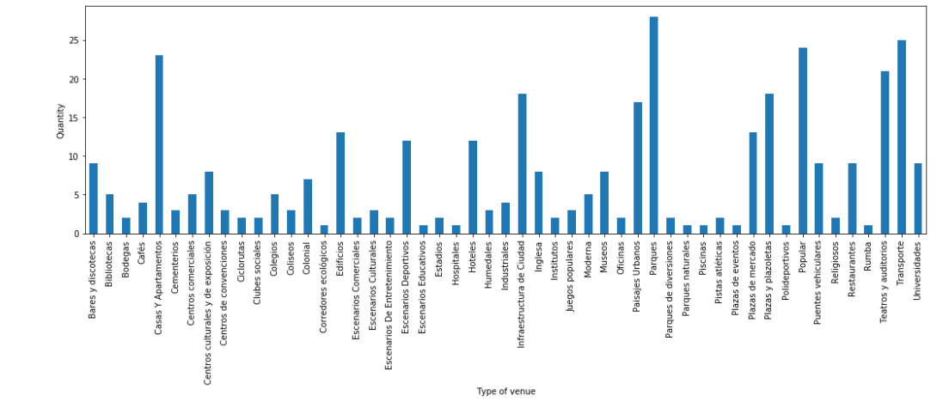  
Table 1. Head part of the general table

Figure 1. Quantity of each venue type.

# **Exploratory Data Analysis**

* 1. **Calculation of target**

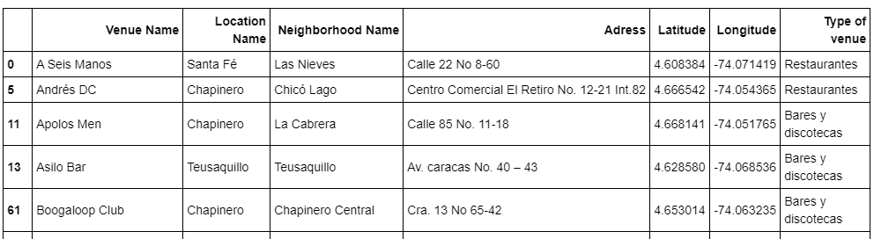As the target of the project was to find the most suitable restaurants or bar venues near to Chapinero location, the data was filtered considering this customer request. Therefore, only the venues with the words “restaurante”, “bar”, “café” o “rumba, were considered.

Table 2. Head part of the filtered table.

As a way of representing the number of places appropriate for the customer, it was decided to plot the next pie graphic:

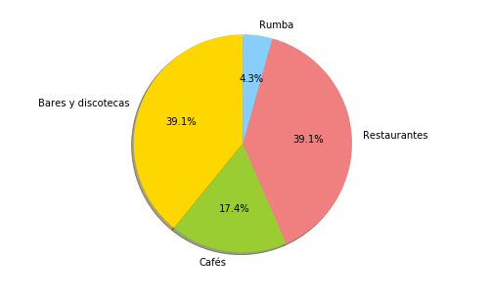

Figure 2. Pie chart showing the number of target venues in Bogotá.

It is possible to say that the highest percentage of the venues in Chapinero are restaurants or bars, according to the previous graph.

* 1. **Representation of the venues in a map**

According to the customer’s demands, it was necessary to show these venues on a map of Bogota. This was made with Geopy and Foluim libraries.

The map shows all the possible venues where the possible could film. These places were registered on the data table and located in Chapinero Location or near.

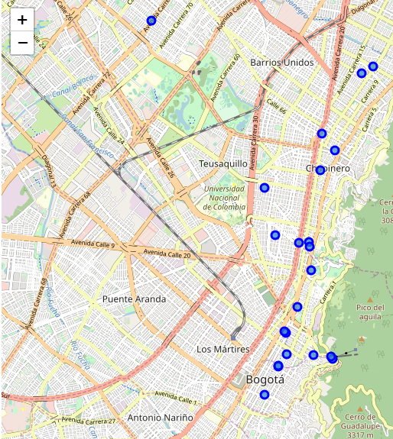

Figure 3. Possible venues where the company could film.

If the customer wanted to see the name and the ubication of each venue, he could do so by clicking on any of them. However, in order to give a better experience with the map and the results found, it was decided to use a clustering algorithm with more venues, and in this way segment and classify the places according to their locations.

# **Clustering Algorithm**

To use the algorithm, the venues were classified only for the towns near Chapinero, which were: La Candelaria, Santa Fé and Teusaquillo. Then to have some more places in mind, Forsquare, latitude and longitude of these locations were used.

Finally, with the use of the k-means algorithm, it was possible to show on the map of Bogotá, the classification of the main places according to their location and type of operation, which in this case should be restaurants or bars.

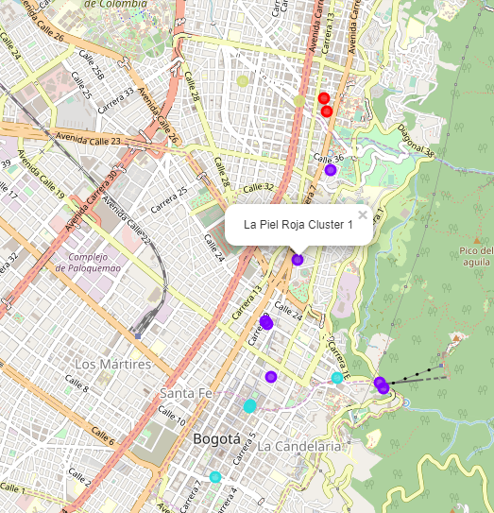

Figure 4. Venues classified according to their location and operation.

**5. Conclusion**

It was found that approximately 65% of places in Chapinero Bogotá, Colombia, are establishments of food or liquor suitable and allowed for the recording of any movie and that in addition to nearby locations there are also several of them.

In addition, with the help of classification algorithms, location tools such as Forsquare, libraries and knowledge on data management in python, it was possible to deliver to the client their request in an organized and simple way to understand.